The chart below shows the results of a survey about people’s coffee and tea buying and drinking habits in five Australian cities.
Summarize the information by selecting and reporting the main features, and make comparisons where relevant.
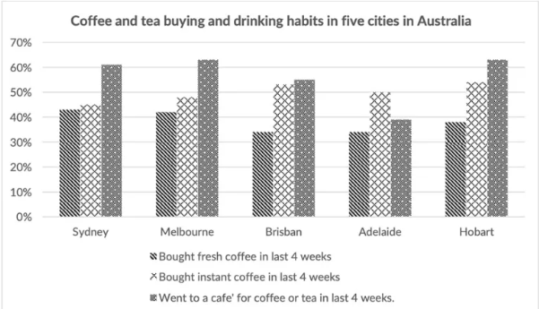
The provided chart illustrates statistical trends related to the percentage of residents in five Australian cities (Sydney, Melbourne, Brisbane, Adelaide, and Hobart), who consumed coffee and tea through three different methods, purchasing fresh coffee, buying instant coffee, and visiting cafés over the past four weeks.
Overall, it is evident that visiting cafés for coffee or tea was the most preferred option in most cities, particularly in Melbourne and Hobart. Instant coffee was also widely consumed, whereas fresh coffee, though popular, showed slightly lower percentages in comparison.
A detailed observation indicates that Melbourne and Hobart recorded the highest proportion of café visitors, at approximately 63% and 62% respectively. Sydney followed closely, with around 61% of residents choosing this option. In contrast, Adelaide had the lowest rate of café-goers, at just under 50%, and a comparatively higher percentage of instant coffee consumers.
In terms of instant coffee purchases, Brisbane and Adelaide led with around 53% and 50%, respectively, while Hobart also showed strong preference at 54%. Meanwhile, fresh coffee consumption peaked in Sydney and Melbourne at 44% and 43%, whereas Brisbane and Adelaide reported the lowest figures, around 34% and 35%.
These figures suggest that while instant coffee and café visits remain highly popular across the five cities, the demand for fresh coffee varies more significantly depending on the region.

